1. a) Using T flip-flops design a 3-bit counter that counts up from 0 to 7 and returns to 0 after 7. (5 points)
b) Using T flip-flops design a 3-bit counter that counts down from 7 to 0 and returns to 7 after 0. (5 points)
c) Use the counters designed in parts a and b and minimum number of external gates, design a 3-bit counter capable of counting in both directions. This counter will be controlled by an external signal called COUNT-DOWN. If COUNT-DOWN is 1 the counter counts down, otherwise it counts up. (10 points)

- a)Use only three flip-flops and minimum number of extra gates to design a counter that counts 4-bit even numbers (0,2,4,6,8,10,12,14) and resets to 0 after 14. Use D, JK and T flip-flops. (Three designs) b) Making minimum changes to your answer to part a design a counter that counts odd numbers (1,3,5,7,9,11,13,15) c) Change your answer to part a so the counter performs both counts based on a control bit called EVEN. If the bit is 1 the counter counts even numbers, if 0 it counts odd numbers.

- Design a sequential circuit with two D flip-flops and one input x. When x=0, the state of the circuit remains the same. When x=1, the circuit goes through the state transitions 00, to 01 to 10 and to 11, back to 00, and then repeats. (15 points)

4. Using T flip-flops design a circuit which detects if either 110 or 111 appear in an input stream. Your circuit receives the bits through a serial input line and sets the output to 1 if either of the combinations appears. Draw the state diagram and the circuit. (20 points)

5. Draw the state table and state diagram for the following circuit. (20 points)
T A

x’

CLK
T B
x

7. Design a 4-bit counter which counts from 1 to 10. The counter goes back to 1 once the count reaches 10. The counter outcome (A3A2A1A0) is produced using four flip flops. A3 is generated by a JK flip flop. A2 is generated by a D flip flop. A1 and A0 are generated using T flip flops. Draw your circuit. (30 points)

8. Consider the logic diagram of the 3-bit binary counter presented below (20 points)

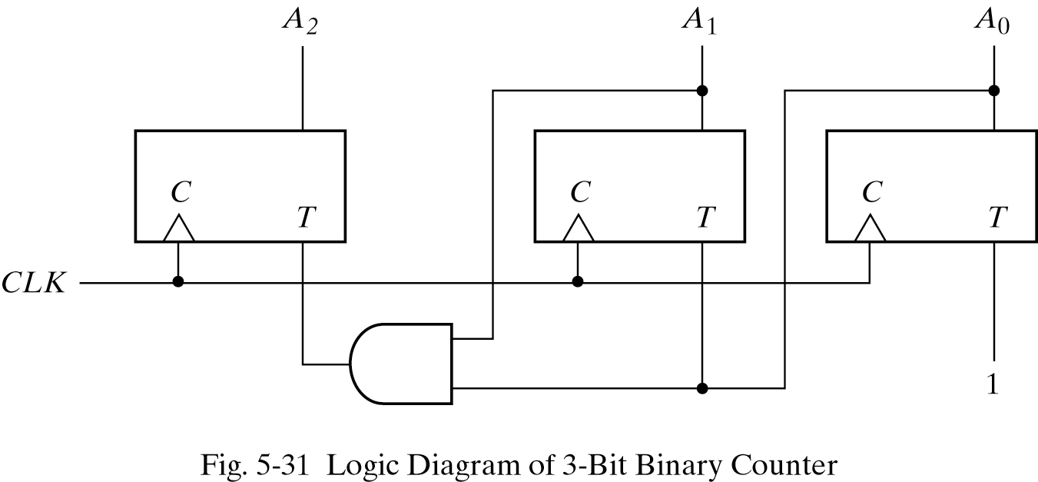

9. Making minimum number of changes, change it to a counter that counts
a) Only odd numbers. (5 points)
b) Only even numbers. (5 points)
c) Only from 0 to 3. (5 points)
d) Only from 4 to 7. (5 points)

