Supplemental Material

Methodological Details
Experiments 1 and 2
Methods
Subjects
In Experiment 1, 15 participants (mean age: 23.2 years, 9 females) and in Experiment 2, 17 subjects (mean age: 21 years, 8 females) were recruited from the University of Western Ontario (London, Ontario, Canada). All participants were right-handed, as determined by the Edinburgh handedness questionnaire (Oldfield, 1971), and had normal or corrected-to-normal vision. Informed consent was obtained in accordance with procedures approved by the University’s Psychology Review Ethics Board. One subject from Experiment 1 and three subjects from Experiment 2 were excluded from analyses due to poor performance (see Data Processing).
Stimuli and Apparatus
Participants were seated in front of a table containing a start button and a touch screen. The start button was located 15 cm from the edge of the table at the subject’s midline and was used to collect reaction times for reach onset. Located 40 cm from the start button (55 cm from subject) was a 40 inch touch screen (NEC MultiSync© LCD4020) that was used to display targets on each trial. Targets were 2-cm diameter black circles (hollow then filled), on a white background, and could be located in various spatial configurations and positions (see Procedure below). Target stimuli and their presentation were controlled using custom Matlab software (version 6.5) using the Psychtoolbox (Version 2, Brainard, 1997; Pelli, 1997). Reaching kinematics were recorded (at 150 Hz) using two infrared emitting diodes (IRED) markers placed on the index finger of the right hand (one on the tip, the other directly behind it) via an OPTOTRAK (Northern Digital Inc., Waterloo, Canada) motion tracking system. Marker wires were held in place with an arm band to allow for unrestricted arm movement. Three IREDs were also placed on the touch screen.

Procedure
Trials began with the subject viewing a black fixation cross (centered on the touch screen) for a variable delay (1000-2000 ms) with their right index finger on the start button. This was replaced by a target display consisting of one or two hollow targets (outline of circle, 4 pixel outline width) and a concurrent audio sound (‘beep’) cuing the subjects to start their reach. Subjects were required to release the start button after 100 ms had elapsed (to prevent anticipatory responses) and before 325 ms. Immediately after subjects released the start button one of the targets in the display filled-in (entire area of outlined circle became black), cuing the subject to correct their point in-flight to that target location. We imposed a movement time limit of 425 ms (from button-release to touch screen contact) so that only rapid reaching responses would be generated. Trials were considered correct if the subject touched the target, 1) with the correct timing and 2) within a 6 cm x 6 cm box centered on the target (not visible to participant). Following the trial, subjects were required to bring their hand back to the start button (1 s before fixation onset) and wait for commencement of the next trial.
At the end of every trial, subjects received the following visual feedback (presented on the touch screen) indicating their performance on that trial: Too Early (if the start button was released before 100 ms had elapsed) which aborted the trial, Time Out (if the start button was not released within 325 ms) which aborted the trial, Too Slow (if the screen was not touched within 425 ms following button-release), Miss (if subjects did not touch the target within a 6 cm x 6 cm box centered on the target - not visible to the participant), and Good (if the target was touched within the allowed timing). On an aborted trial (Too Early or Time Out) possible targets did not appear on the screen. For analysis of errors see Error Analysis and supplemental Figure 2.
Target displays were selected from four possible targets arranged in a 12 cm square (target centers at each corner of the square, see Figure 1), centered on the fixation cross. Single target centers were therefore located in the upper left (6 cm up, 6 cm left from fixation), upper right (6 cm up, 6 cm right), lower left (6 cm down, 6 cm left) or lower right (6 cm down, 6 cm right) quadrant of the touch screen. In Experiment 1, in the single target cases (4 conditions), subjects knew in advance what target would be filled-in at movement onset (since there was only one possible target) and could plan their trajectories accordingly. The two target trials could be aligned 1) horizontally in either the upper (upper left and upper right target locations) or lower (lower left and lower right target locations) visual fields, 2) vertically in either the left (upper left and lower left target locations) or right (upper right and lower right target locations) visual fields or 3) diagonally (upper left and lower right; upper right and lower left target locations). Importantly, each target in these trials had an equal probability of filling in at movement onset. Thus in these two target cases, as subjects planned their initial trajectory prior to movement, they were uncertain as to which target would be selected for action. This gave 12 possible conditions in which two targets appeared (for example of all target displays used, see supplemental Table 1).
The design, stimuli and timings of Experiment 2 were exactly the same as in Experiment 1 with two major exceptions: 1) On all trials, two targets appeared on the screen and were only configured horizontally in either the upper (upper left and upper right target locations) or lower visual fields (lower left and lower right target locations) and 2) the final target could be filled-in at movement onset (‘Late’ trials; similar to all trials in Experiment 1) or, at the time the target display first appeared (‘Early’ trials). Thus, in ‘Early’ trials, despite two targets being presented in the display, the final target was already cued before reach initiation (i.e. similar to single target trials in Experiment 1). The purpose of this second experiment was to control for the potential distracting effect of the non-selected target in two-target trials in Experiment 1. Experiment 2 had a total of 8 conditions - each of two endpoints within the 2 displays listed above for both early and late timings (for example of all target displays used, see supplemental Table 1).
Both experiments were divided into blocks of trials to avoid arm/shoulder and attentional fatigue. In Experiment 1, subjects were required to perform 32 correct trials per block (2 each of the 16 conditions) and complete ten blocks in total (~ 1 hour to complete). Trials were pseudo-randomly ordered within a block. This provided 320 correct trials per subject and twenty repetitions per condition for analyses. Experiment 2 was shorter in duration (~25 min) and required that subjects perform 8 correct trials per block (1 each of 8 conditions) before proceeding to the next block of trials (for a total of ten blocks). This resulted in 80 correct trials per subject with ten repetitions per condition. Subjects were allowed to rest in between blocks and indicated when they wished to resume testing. Before starting either experiment, participants were given at least one and up to three practice blocks of trials (with the same completion criteria as above) until they reported being comfortable with the procedure and timing.

Data Processing
Participants were excluded from analysis if they made errors (‘Too Early’, ‘Too Late’, ‘Too Slow’ or ‘Miss’) on more than 50% of the two-target trials (Experiment 1) or ‘Late’ trials (Experiment 2). This led to the removal of one participant in Experiment 1 and three participants in Experiment 2, resulting in n=14 for both experiments. Only ‘Good’ trials from the remaining participants were analyzed. For a detailed breakdown of the types of errors made see Error Analysis and supplemental Figure 2.
All analyses were conducted on data from the IRED on the tip of the right index finger. Raw 3D data for each trial was filtered using a low-pass Butterworth filter (dual pass, 8 Hz cutoff, 2nd order). Instantaneous velocities in each cardinal dimension (x,y,z) were calculated for each time point and the resulting velocity profiles were filtered (low-pass Butterworth filter, dual pass, 12 Hz cutoff, 2nd order) and combined to create a vector velocity (i.e. three-dimensional) profile for each trial. Onset of reaches were defined as the first of four consecutive vector velocity readings of greater than 20 mm/s where there was a total acceleration of 20 mm/s² across the four points. Reaches were said to terminate with whichever of two conditions was first met: the maximum value in the y-direction was obtained or the first time the velocity dropped below 20 mm/s.
Missing data from the index finger-tip IRED that was temporarily blocked from the view of the OPTOTRAK was filled in with translated data from the second index-finger IRED immediately behind it. When both IREDs were missing, the data were linearly interpolated across the missing region. Linear interpolation was required on 10% of analyzed trials for Experiment 1 and 2% of trials for Experiment 2, and, where required, was interpolated across an average of 11 time points in Experiment 1 and 7 time points in Experiment 2.
Trials were also rejected for the following reasons: the reach never attained the defined minimum velocity, the reach did not terminate within the recording window, the reach was too short in either duration (<100 ms) or distance (<200 mm in depth), or errors in OPTOTRAK recording (usually due to blocked IREDs) caused velocity spikes >6000 mm/s. Under these criteria, 1% of the trials in Experiment 1 and 2% in Experiment 2 were rejected.
All trajectories were translated such that the first reading of the index-finger-tip IRED was taken as the origin of the trajectory (i.e. 0,0,0 in 3D Cartesian space, x = horizontal, y = depth, z = vertical). They were then rotated such that the direction of movement (y) was orthogonal to the plane of the touch screen (defined by the IREDs on the screen).
Spatial averaging of trajectories used functional data analysis techniques (Ramsay & Silverman, 2005 – for website with downloadable code see: http://www.psych.mcgill.ca/misc/fda/). For each participant and each trial, the discrete data in the extracted reach trajectory was fit using B-splines. Spline functions are commonly used to fit motion data that are not strictly periodic (For an example of recent papers using a similar technique see Loehr & Palmer, 2007; Loehr & Palmer, 2009; Ramsay, 2000; Ramsay, Munhall, Gracco, & Ostry, 1996). Order 6 splines were fit to each of the three dimensions (x,y,z) of the motion data with a spline at every data point. The data were smoothed using a roughness penalty on the fourth derivative (λ = 10^{–18}, within 0.00001 of the generalized cross-validation estimate; Ramsay & Silverman, 2005), which allowed for control of the smoothness of the second derivative.
The result of the spline-fitting process is a functional data object for each of the three dimensions that contains a mathematical formulation of the reach. Since the trajectory was now mathematically defined, we could define the reach at any scale (i.e. with any number of points). Therefore, to average our trajectories, we evaluated each of the y (reach direction) components of the reach at 2000 equally spaced points (in time). We then extracted the location and times that corresponded to 200 points that were equally spaced along the distance of the y-trajectory. We were therefore able to now proceed with spatial averaging that corresponded to trajectories normalized to y-distance (which will be comparable for all reaches made to the touch screen which remained at a fixed distance). To do so, we evaluated both the x and z components of the reach at the newly y-normalized times then averaged across trials within the same condition for each subject, and finally across subjects to produce our average trajectory plots.
Functional Analysis
Within each display (for example Horizontal Top) a functional-ANOVA (Ramsay & Silverman, 2005) was used to evaluate trajectory differences in both the lateral (x) and vertical (z) dimension. A functional-ANOVA is an extension of the traditional ANOVA (with only a single dependent variable across groups) to data that is continuous (like the spline-fitted trajectories in the current experiment). Therefore, where a traditional ANOVA gives a single F-statistic which indicates differences among means, the functional-ANOVA gives a functional F-statistic which shows not only if, but where, a set of functionally defined measures differ across conditions. We therefore report the regions where our conditions significantly differ by placing significance bars to the side of our trajectories that correspond to the specific comparisons being made.
The functional-ANOVA model used in Experiments 1 and 2 was a single factor repeated measures design (n=14) with four levels corresponding to the four trajectories that occurred within any given display (the two single-target conditions and the two two-target conditions). The functional-ANOVA was considered significant anywhere where the corrected p-value of the F-statistic was < 0.05. A Greenhouse-Geisser correction for sphericity was applied separately for each of the 200 points evaluated in each of the x and z trajectories. Where this functional-ANOVA was significant is indicated with grey bars in Figures 2 and 3.
Given that the first two experiments were exploratory we were conservative with our follow-up analysis and performed, and corrected for, all possible pairwise comparisons between individual trajectories within each display. Of critical interest were the comparisons between the single and two-target trajectories that shared a common endpoint as well as the comparisons between the two two-target trajectories. We implemented these functional comparisons as two-level repeated measures functional-ANOVAs (equivalent to a paired t-test) and adjusted for significance using a Bonferroni correction within each display (p < 0.05/6). Where two-target trajectories significantly differed from the single-target trajectories with a common endpoint is indicated with light-blue significance bars (for blue-trace vs. green-trace comparisons) and dark-red significance bars (for red trace vs. black trace comparisons). Where the two-target trajectories differed from each other (i.e. blue-trace vs. red-trace) is indicated with a pink significance bar (see Figures 2 and 3).

Experiment 3
Methods
In Experiment 3, 22 right-handed participants (mean age: 22 years, 9 females) took part in testing. Four subjects were excluded from analyses due to poor performance (see Data Processing). All stimuli, apparatus and timings were the same as in previous experiments with the exception that we changed the possible target positions as well as the possible number of targets appearing on the screen. We continued to use four possible target positions, but instead of being arranged as a square (as in Experiments 1 and 2), they were aligned horizontally at the same height as the fixation cross. In addition to target centers 6 cm to the left and right of midline (inside/left and inside/right), we included two ‘wider’ positions, 12 cm to the left and right of midline (outside/left and outside/right). Target displays consisted of a single target, two-targets or three-targets. Single targets could appear at any of the four possible positions. In two and three target displays, at least one target always appeared in the left visual field (inside or outside position) and at least one target always appeared in the right visual field (inside or outside). On three target trials, on whichever side the two targets appeared they were ‘stacked’ at the same horizontal position (inside or outside) and their centers were separated vertically by 3 cm. In this way, the display width of the targets could be held constant while the possible number of targets was systematically manipulated.
Trials were equally distributed across all possible positions and left-right position pairings. This created four single target conditions. For multiple target displays (two- and three-target trials), this created four left-right position pairings: Left-In/Right-In, Left-Out/Right-in, Left-In/Right-Out and Left-Out/Left-In. Within each pairing, there were three possible target configurations: 1-left/1-right, 2-left/1-right or 1-left/2-right. For these multiple target displays, trials with an endpoint to the left were considered separately from trials with an endpoint to the right, which provided a total 24 conditions (4 pairings x 3 configurations x 2 sides of space) [see supplemental Table 1 for schematic of all target displays used]. As in Experiment 1 and ‘Late’ trials in Experiment 2, the selected target was filled-in at movement onset and all targets in the display had an equal probability of being selected. As such, for three-target displays, despite the subject not knowing prior to their reach the final location of the selected target, the probability of acting on a particular side of space (left or right) was biased (2/3) towards the side of space containing the greater number of targets. We repeated each of the 4 single-target conditions 15 times and each of the multiple-target conditions 30 times, providing a total of 420 trials, distributed randomly across 10 blocks. In contrast to Experiments 1 and 2, participants were not required to obtain a certain number of correct trials per block to proceed through the experiment.
Data Processing
Participants were excluded from analysis if they made errors (‘Too Early’, ‘Too Late’, ‘Too Slow’ or ‘Miss’) on more than 50% of all the two- and three-target trials. This led to the removal of 4 participants in Experiment 3, leaving n = 18 for all analyses. Due to the introduction of more display-types we were required to reduce the number of repetitions per display type. In order to better estimate each participants average reach behavior, we therefore analyzed both the ‘Good’ trials and trials that were ‘Too Slow’, provided that the total movement time for an included ‘Too Slow’ trial was within one standard deviation of that participants mean movement time for the entire experiment.
The filtering of the raw data and extraction of trajectories was identical as in Experiments 1 and 2. We used the same interpolation procedures as in Experiments 1 and 2 for missing data (2% of trials with linear interpolation, with an average of 11 time points). Due to the position of the screen, the larger display widths, and the wrist rotation of some participants, some trials had blocked IREDs for the last few centimetres of the reach. On these trials (final recorded position more than 1.5 cm from IRED on screen) we used the touch screen coordinates to infer the final OPTOTRAK position and used a linear interpolation (at an average velocity) to fill the remainder of the trajectory. If the inferred position was more than 2 cm from the final recorded OPTOTRAK position (usually due to the knuckle or hand hitting the screen), we rejected the trial. The touch screen inference was required on 437 trials, with 397 being successfully filled and 40 being rejected. Identical translation, rotation and spline-fitting algorithms were applied to the extracted trajectories as in Experiment 1 and 2.

Functional Analysis
Given the increased number of conditions, subsequent reduction in estimation of mean performance, and the relative subtlety of the manipulations, we used the results from Experiments 1 and 2 to plan specific pairwise functional comparisons (2 level repeated measures functional ANOVAs) in Experiment 3. To analyze the effect of display-width, we compared reaches to one endpoint when the target in the opposite field shifted from an inside (blue-traces Figure 4A) to an outside (red-traces Figure 4A) position. The pink significance bars in Figure 4A depict where the comparison between the inside (blue) and outside (red) traces significantly differed (p < 0.05). To analyze the effect of the number of targets, we conducted four planned comparisons for reaches made to displays sharing two common endpoints (Figure 4B). We compared 1) Reaches to three-target displays ending on the left side of space of a 2-Left/1-Right display (blue-traces Figure 4B) vs. reaches to the same location on a 1-Left/2-Right display (red-traces Figure 4B); 2) The same for reaches to three-target displays ending on the right side of space; 3) The 2-left/1-right reaches that ended left vs. ended right (comparison of the two blue-traces in Figure 4B) and 4) The 1-left/2-right reaches that ended left vs. right (comparison of the two red-traces in Figure 4B). Where these planned comparisons reached significance (p<0.05) are indicated in Figure 4B by 1) pink bar on the left, 2) pink bar on the right, 3) blue bar and 4) red bar, respectively.
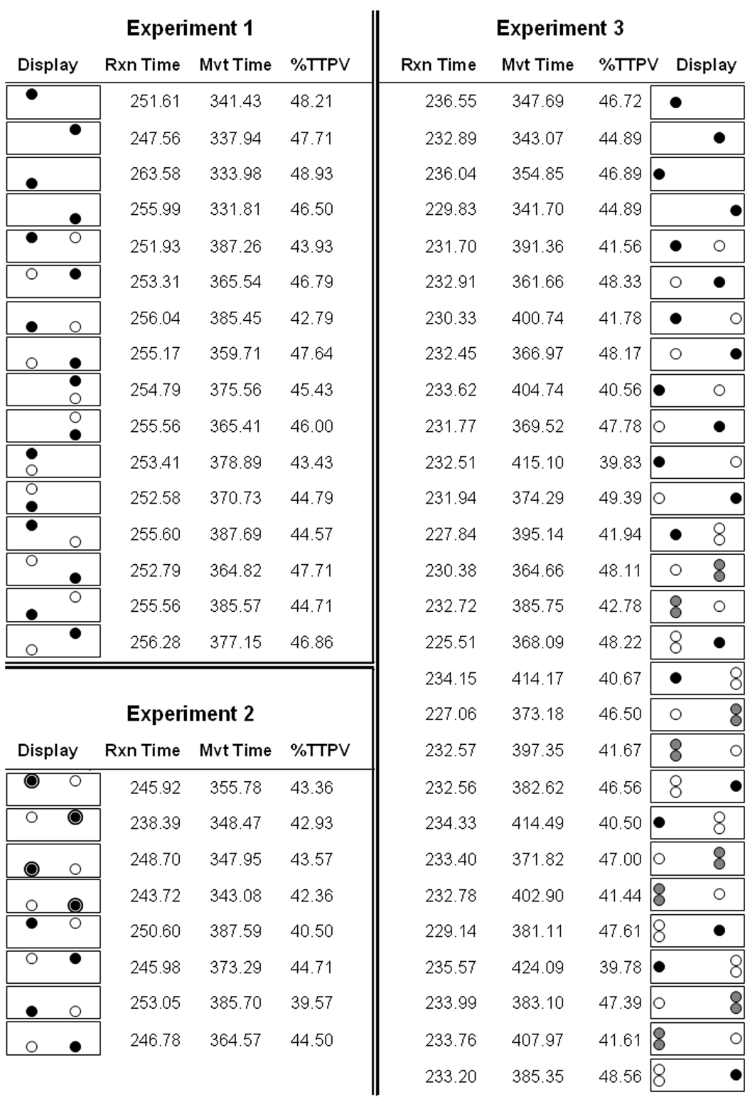
Supplemental Table 1: Means of the three kinematic measures (Reaction Time (ms), Movement Time (ms) and Percent Time to Peak Velocity (%)) across all conditions in each of the three experiments. Conditions are indicated with schematic displays (not to scale) with the cued location filled-in black. Outlined targets for Experiment 2 displays indicate Early trials. Gray targets for Experiment 3 displays indicate that either of those locations was randomly selected on those trials.
Additional Analyses
Experiments 1 and 2
Error Analysis
In Experiment 1 we collected 10 blocks of 32 good trials from each participant (n=14, one participant contributed 9 blocks due to experimenter error) resulting in 4448 good trials for analysis. Participants made a total of 1863 errors in this experiment. 63 trials (4 good, 59 error) were removed (and excluded from all analysis) due to recording errors (see above). Therefore the overall error rate in Experiment 1 was 29.7%. The breakdown of these errors is shown in supplemental Figure 2, where we show a breakdown by type of error (first row), by number of targets (second row) and by location of final cued target position (third row). As can be seen, the most commonly occurring type of error were “Too Slow” errors, which is not surprising given the narrow time limits we imposed on the reaches (<425ms). There were very few “Too Early” errors, indicating subjects were successfully waiting for the go cue (‘beep’) and not anticipating it. The remaining errors were relatively evenly divided between “Too Late” and “Miss”. We can also see that more errors were made on two-target trials, which is to be expected given both the increased difficulty of in-flight corrections as well as the increased number of two- vs. one-target trials. Finally, with respect to location, we see that more errors were made when the final cued target position was on the left side of the touch screen, than when it was on the right. This likely reflects the rightward trajectory bias we will discuss below.
In Experiment 2 we collected 10 blocks of 8 correct trials from each participant (n=14) resulting in 1120 good trials for analysis. Participants made a total of 259 errors in this experiment. 23 trials (1 good, 22 error) were removed and excluded from analysis due to recording errors. As such, the overall error rate in Experiment 2 was 17.4%. The breakdown of errors is shown in supplemental Figure 2 and follows the similar pattern observed in Experiment 1; ‘Early’ trials showed similar errors as the single-target trials, and the ‘Late’ trials showed the same error pattern as the two-target trials - consistent with the overall similarity in behavior that we show between these conditions.
Kinematic Analysis
We calculated participant averages on three dependent measures to characterize the temporal component of the reaches:
Reaction Time (ms): Time from the start of the trial (‘beep’) to the start button release.
Movement Time (ms): Measured as the time between start button release and touch screen contact.
Percent Time to Peak Velocity (%): The percent of movement time spent accelerating (Time to Peak Velocity / Movement Time).
The analysis of the three kinematic variables in Experiment 1 and 2 reveal a consistent pattern of results. For brevity, we report only a sample selection of statistical comparisons which are representative of these effects. For the reporting of all means across all conditions, refer to supplementary Table 1. For reaction time, there seems to be a small but significant advantage for responding to targets that appear in the upper vs. lower visual field. This is most clearly manifested in Experiment 1 by comparing the reaction time on single-target trials with a target in the top right location (248 ms) with those to the bottom left (264 ms), t(13) = 5.87, p<0.001. In Experiment 2 the average reaction time to all trials with targets in the top positions (245 ms) was also significantly faster than the reaction time to all trials with targets in the bottom positions (248 ms), t(13) = 2.41, p<0.05.
We also wanted to maximize our power and examine whether the addition of a second target on the screen changed participants’ reaction times. We therefore collapsed all single-target trials and all two-target trials in Experiment 1 and conducted a paired t-test which showed no significant difference (single-target: 254ms, two-target: 254ms, t(13 )= 0.178, p = 0.86). In Experiment 2, a similar comparison showed that reaction times on ‘Early’ (244ms) trials were significantly faster than reaction times on ‘Late’ trials (249ms), likely a small (5ms) advantage conferred by early target selection.
For movement time and percent time to peak velocity there were three major effects. First, single-target (Experiment 1) and ‘Early’ (Experiment 2) trials had shorter movement times than the two-target and late trials (e.g. for Experiment 1: 2-Horizontal-Top-Left (387 ms) > 1-Top-Left (341 ms), t(13) = 8.33, p<0.001 and for Experiment 2: Late-Bottom-Left (386 ms) > Early-Bottom-Left (348 ms), t(13) = 5.96, p<0.001). This observation is not surprising as the in-flight correction required on the two-target/’Late’ trials leads to a spatially longer trajectory. This extra time spent correcting largely affects the deceleration phase as the percent time to peak velocity is less for two-target/’Late’ trials compared to the single-target/early trials (e.g., for Experiment 1: 2-Horizontal-Top-Left (43.9%) < 1-Top-Left (48.2%), t(13) = 4.30, p<0.01 and for Experiment 2: Late-Bottom-Left (39.6%) < Early-Bottom-Left (43.6%), t(13) = 4.44, p<0.001 ). This prolongation of deceleration when correcting is a well known phenomena of corrected movements (e.g. for review see Glover, 2004; Paulignan, Jeannerod, MacKenzie, & Marteniuk, 1991). The second major effect is that a correction of movement to the left resulted in longer movement times than a correction to the right (e.g. for Experiment 1: 2-Horizontal-Top-Left (387 ms) > 2-Horizontal-Top-Right (366 ms), t(13) = 5.16, p<0.005 and for Experiment 2: Late-Bottom-Left (386 ms) > Late-Bottom-Right (365 ms), t(13) = 7.24, p<0.001), again a well-established (and likely biomechanical) result (e.g. Carey, Hargreaves, & Goodale, 1996; Carnahan, 1998; Rossit & Harvey, 2008). These longer left-correction movement times were again manifested in the deceleration phase, resulting in lower percent time to peak velocity values (e.g for Experiment 1: 2-Horizontal-Top-Left (43.9%) < 2-Horizontal-Top-Right (46.8%), t(13) = 4.14, p<.01 and for Experiment 2: Late-Bottom-Left (39.6%) < Late-Bottom-Right (44.5%), t(13) = 4.45, p<0.001). The third major effect concerned only single-target/’Early’ trials, as characterized by more time spent accelerating - suggesting slightly different kinematics for reaches toward targets on the left than targets on the right. This is reflected by longer percent time to peak velocity (slightly significant only in Experiment 2: Early-Bottom-Left (43.6%) > Early-Bottom-Right (42.4%), t(13) = 2.40, p<0.05) and again likely reflects the biomechanics (e.g. engagement of different muscle groups) of reaching your right hand across your body to left targets.

Analysis of midpoint trajectories: were subjects arbitrarily guessing on two-target trials?
The results of Experiment 1 demonstrate that when subjects are simultaneously presented with two equally likely targets, they immediately initiate reaching trajectories aiming for their midpoint before correcting in-flight to the cued target location (see Figures 2 and S1A). An anticipated criticism of these findings is that our observed two-target midpoint trajectories could simply reflect an averaging of subject ‘guesses’ – that is, averaging together cases where they randomly aim to the right or left target. In other words, because we spatially averaged trajectories (first within and then between subjects), the ‘middling’ trajectories observed here, as an extreme example, could also be produced by averaging together all single target trajectories to the left and right targets (i.e. green and black traces in Figure S1A). To test for this alternative explanation of our averaging behaviour, we took lateral deviation (x) values at 200 mm into the reach (a distance where two-target trials did not statistically differ) from all subjects for one of the target displays used in Experiment 1 (see Figure S1A). We plotted these lateral deviation values as both a function of density (Figure S1B) and cumulative probability (Figure S1C). Consistent with what would be expected for relatively straight trajectories to different target locations, Figure S1B shows two distinct distributions for single target trials (green and black distributions). Importantly, this is contrasted with the overlapping and more dispersed unimodal distributions for two-target trials (red and blue distributions). This confirms that subjects did not arbitrarily guess left or right (as this would have led to a bimodal distribution with peaks similar to the single-target distributions) but instead opted for an initial trajectory in between the possible target locations. Figure S1C shows the same data plotted as the cumulative probability of the lateral deviations (unsmoothed traces), fit with a normal distribution (smoothed traces) along with the corresponding 95% confidence intervals for the fit (dashed traces). In agreement with the previous density analysis, the cumulative probabilities show that reaches toward two-target displays produce lateral deviations that fall statistically between the deviations from reaches to single target locations. Taken together, these complimentary analyses definitively show that our observed trajectories were not the result of subjects randomly guessing in two-target display trials.
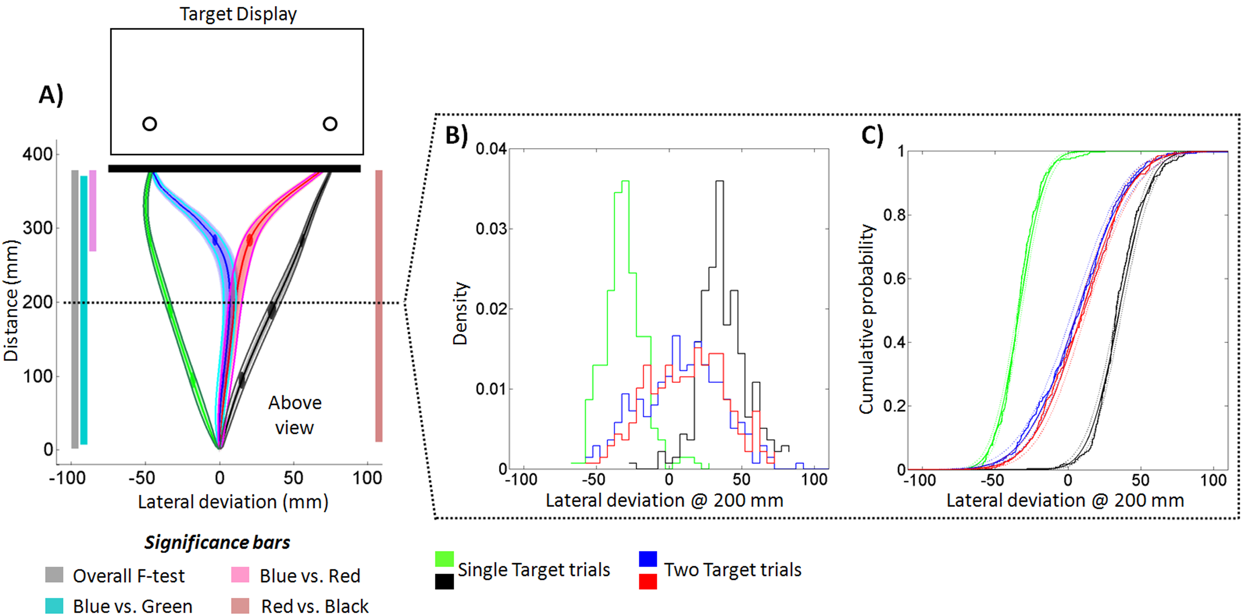
Supplemental Figure 1: Average reach trajectories (14 subjects) with accompanying density histograms and cumulative probabilities from Experiment 1. A: Trajectories to the Horizontal Bottom display, shown from Above view. Tubes around trajectory traces represent average standard error (ASE) across 14 participants with darkened spheres at 25%, 50% and 75% of reach distance proportional to the velocity. For comparison we also show the standard error of the mean (SEM: dark green, cyan, magenta and gray lines parallel to corresponding trajectories). Significance bars give a measure of where there were statistical differences (Greenhouse-Geisser corrected repeated measures ANOVA, p < 0.05) between trajectories in the lateral dimension. Note that while the ASE and SEM are similar in magnitude, the ASE better corresponds to where statistical differences emerge. The target display (at top) is not drawn to scale. All lateral deviation (x) values at 200 mm into the reach (a distance where two-target trials did not statistically differ, blue and red traces) were taken from all subjects and plotted as both a density histogram (B) and cumulative probability (C). B: Density histograms for single- and two-target trials for lateral deviations at 200 mm reach distance. C: Cumulative probabilities plotted for single and two target trials (unsmoothed traces), fit with a normal distribution (smoothed traces) along with the corresponding 95% confidence intervals of the fit (dashed traces).

Analysis of rightward bias
A careful examination of these results also reveals a subtle rightward bias in the initial trajectories made toward two-target displays. This can be seen as slight rightward shift in the centers of the two target distributions in the density plots (Figure S1B) as well as the increasing probability of a two target reach (red and blue traces) appearing to the right of midline at half the reaching distance (Figure S1C). Given the narrow movement time constraints of our reaching task (< 425 ms), this initial bias (likely reflecting the biomechanics of the right arm) is expected to affect the ability of subjects to make viable corrections to cued targets on the left. Consistent with this rationale, kinematic and error analyses for Experiments 1 and 2 (see above) show that subjects require significantly more movement time (and time post-peak velocity) and make more errors when the final cued target position in two-target trials appears on the left vs. right (see supplemental Table 1 and Figure S2).

Experiment 3
Error Analysis
Recall that in Experiment 3, instead of collecting a certain number of ‘Good’ trials, we collected the same number of trials for each participant. We therefore had 10 blocks of 42 trials per participant (n=18) for a total of 7560 trials. From these we had 89 trials (1.2%) with recording errors that were removed and excluded from analyses. This left 836 error trials for an overall error rate of 11.2%. This error rate was expected to be significantly lower than that seen in Experiments 1 and 2 due to the fact that we now included “Too Slow” trials that were within one standard deviation of the participants’ movement time mean (see above). This inclusion of “Too Slow” trials is also reflected in the breakdown of errors by type shown in supplemental Figure 2. Specifically, the “Too Slow” errors no longer contribute the largest proportion of the errors, but rather the “Miss” and “Too Late” trials are now the largest contributors. There is a slight increase in the number of “Miss” errors, likely due to the longer distance the hand was required to travel in the displays with widely spaced targets. The distribution of errors across displays with different numbers of targets is repeated with the addition that now three-target trials account for the most errors – again likely due both to their relative frequency (i.e. the largest proportion of trials had three-targets) and their relative difficulty.
At first glance the pattern of errors across the four target locations appears puzzling – why would participants make more errors to the target locations closer to the center of the display? We believe this reflects a bias that some participants had to point towards any target appearing in either of the outside locations. In related work it has been shown (under much different circumstances) that widely spaced targets forces participants to guess more often, rather that compromise, between targets (e.g. Ghez et al., 1997). We believe a similar strategy may have been employed here with a bias toward targets that were further (and harder) to reach to. Therefore, when an Inside target was paired with an Outside target, and participants were biased to point to the Outside target, this resulted in more errors, but only on trials when the target actually filled-in at the Inside location. In contrast, on those same trials, if the target filled-in at the Outside location, participants by virtue of the bias would not make errors. The net result is the distribution we see in the errors, with a higher percentage of error trials made on displays when the target filled in at an Inside relative to an Outside location.

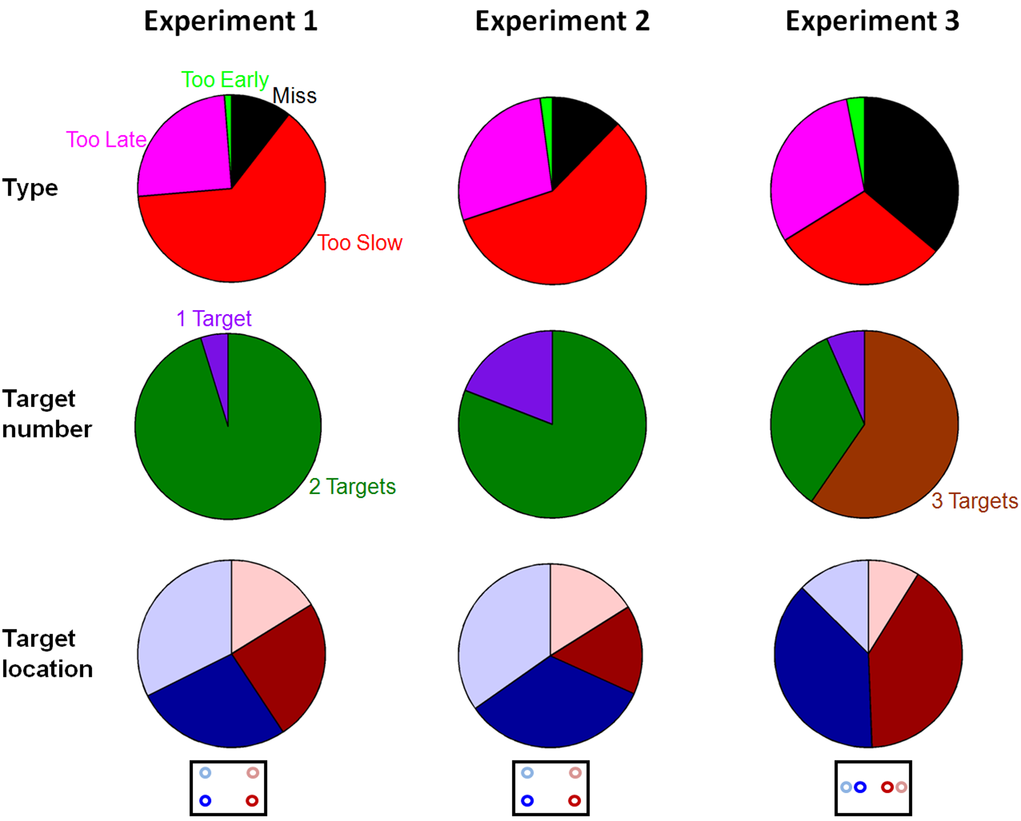
Supplemental Figure 2: Distribution of all errors made in the three experiments (columns) by type (first row), target number (second row) and target location (note change in locations for Experiment 3 compared to Experiments 1 and 2). Pie-chart areas are representative of the total number of errors made within each category (i.e. not a percentage). Note, the color of the pie-segments and labels in the top-row correspond to the actual text and color of the feedback that was given on the touch screen to participants following each trial.

Additional Trajectory Analysis
We were interested in exploring whether your ability to react to the cueing of the target (filling-in) was dependant on the number of targets present. We therefore ran one additional functional comparison that compared where trajectories made toward the two-target (both Inside) display differed when the target was cued to the left (blue-trace Figure 4A, left panel) versus when it was cued to the right (blue-trace Figure 4A, right panel). These two trajectories significant differ (where p<0.05) at 61% or 24cm of the y-movement. Although this value is difficult to directly compare (as they are all based on group averages) to the values reported for the three-target displays (65% for two-targets-left and 55% for two-targets-right) it appears that the time it takes for you to correct is similar regardless of the number of targets on the screen. This fits well with the literature on online correction which reports a relatively consistent value for the initiation of in-flight corrections (Glover, 2004; Goodale, Pelisson, & Prablanc, 1986; Pisella et al., 2000).
Kinematic Analysis
The same three kinematic markers were analyzed for Experiment 3 (Reaction Time, Movement Time and Percent Time to Peak Velocity).
The analysis of the three kinematic variables in Experiment 3 reveal a pattern of results that is consistent with those observed in the first two experiments. For brevity, we again report only a selection of statistical comparisons which are representative of these effects. For the reporting of all means across all conditions, refer to supplementary Table 1. In Experiment 3, an omnibus comparison of reaction time across all the different conditions did not reach significance, so therefore we conclude that reaction time was not affected by our displays/configurations in Experiment 3. This is consistent with the results from Experiment 1 and 2 where reaction time effects were driven by vertical display differences (upper vs. lower visual field), a factor that was not manipulated in the third experiment. Despite the lack of a reaction time effect, for completeness we conducted the same latency analysis for Experiment 3 that was explained in the main text for Experiments 1 and 2. Specifically, we looked at all trials where there was more than one uncued target on the screen (two- and three-target trials). Each participant’s latency distribution on these trials was grouped into bins of 20% (quintiles) and the deviation toward the distractor averaged for each bin. Similar to Experiments 1 & 2, a Greenouse-Geisser corrected repeated-measures ANOVA of maximum deviation toward the distractor across the five quintiles was not significant (0-20%: 24.92mm, 20-40%: 23.73mm, 40-60%: 24.30mm, 60-80%: 25.61mm and 80-100%: 25.16mm,[ F(2.7,46.4) < 1, p = 0.64]). Additionally, we examined whether the addition of multiple targets had a direct effect on reaction time by collapsing across all trials with a single target and performing a paired t-test against all trials with more than one target. This also failed to reach significance (single-target trials: 234ms, multi-target trials: 232ms, t(17 )= 1.53, p = 0.15).
For movement time and percent time to peak velocity there were three major effects which directly paralleled the results from Experiments 1 and 2. First, trials requiring a correction (two- or three-target trials) resulted in longer movement times compared to single-target trials (e.g. 2-Inside/Left-&-Inside/Right-Right (362 ms) > 1-Inside/Right (343 ms), t(17) = 7.19, p<0.001). Second, corrections to the left took more time, with shorter percent time to peak velocities (longer deceleration) than corrections to the right (e.g. 2- Inside/Left-&-Inside/Right-Left (391 ms, 41.6%) > 2-Inside/Left-&-Inside/Right-Right (362 ms, 48.3%), movement time: t(17) = 13.26, p < 0.001, percent to peak velocity: t(17) = 11.33, p < 0.001). Finally, reaches to single targets on the left had longer accelerations (lower percent time to peak velocities) than reaches to single targets on the right (e.g. 1-Inside/Left (46.7%) > 1-Inside/Right (44.9%), t(17) = 3.00, p < 0.05). Unique to Experiment 3, where we manipulated display width, we found that the further you had to reach for targets to the left, the longer the movement took (e.g. 1-Outside/Left 355 ms > 1-Inside/Left 348 ms). Surprisingly, this same pattern did not hold to the right, where reaches to the Inside and Outside locations were more similar in movement time (1-Outside/Right (342 ms) < 1-Inisde/Right (343 ms)). While these results do not meet statistical significance, the faster movements to the Outside-Right location are probably biomechanical in nature, and are likely a large contributing factor to the rightward bias, and a reflection of the Outside guessing strategy we describe earlier.

References:
Brainard, D. H. (1997). The Psychophysics Toolbox. Spat Vis, 10(4), 433-436.
Carey, D. P., Hargreaves, E. L., & Goodale, M. A. (1996). Reaching to ipsilateral or contralateral targets: within-hemisphere visuomotor processing cannot explain hemispatial differences in motor control. Exp Brain Res, 112(3), 496-504.
Carnahan, H. (1998). Manual asymmetries in response to rapid target movement. Brain Cogn, 37(2), 237-253.
Ghez, C., Favilla, M., Ghilardi, M. F., Gordon, J., Bermejo, R., & Pullman, S. (1997). Discrete and continuous planning of hand movements and isometric force trajectories. Exp Brain Res, 115(2), 217-233.
Glover, S. (2004). Separate visual representations in the planning and control of action. Behavioral and Brain Sciences, 27(1), 3-24; discussion 24-78.
Goodale, M. A., Pelisson, D., & Prablanc, C. (1986). Large adjustments in visually guided reaching do not depend on vision of the hand or perception of target displacement. Nature, 320(6064), 748-750.
Loehr, J. D., & Palmer, C. (2007). Cognitive and biomechanical influences in pianists' finger tapping. Exp Brain Res, 178(4), 518-528.
Loehr, J. D., & Palmer, C. (2009). Sequential and biomechanical factors constrain timing and motion in tapping. J Mot Behav, 41(2), 128-136.
Oldfield, R. C. (1971). The assessment and analysis of Handedness: the Edinburgh inventory. Neuropsychologia, 9, 97-113.
Paulignan, Y., Jeannerod, M., MacKenzie, C., & Marteniuk, R. (1991). Selective perturbation of visual input during prehension movements. II. The effects of changing object size. Experimental Brain Research, 87(2), 407-420.
Pelli, D. G. (1997). The VideoToolbox software for visual psychophysics: transforming numbers into movies. Spat Vis, 10(4), 437-442.
Pisella, L., Grea, H., Tilikete, C., Vighetto, A., Desmurget, M., Rode, G., et al. (2000). An 'automatic pilot' for the hand in human posterior parietal cortex: toward reinterpreting optic ataxia. Nat Neurosci, 3(7), 729-736.
Ramsay, J. O. (2000). Functional components of variation in handwriting. Journal of the American Statistical Association, 95, 9-15.
Ramsay, J. O., Munhall, K. G., Gracco, V. L., & Ostry, D. J. (1996). Functional data analyses of lip motion. J Acoust Soc Am, 99(6), 3718-3727.
Rossit, S., & Harvey, M. (2008). Age-related differences in corrected and inhibited pointing movements. Exp Brain Res, 185(1), 1-10.

