Supplemental Material

Methodological Details
Stimuli and Apparatus
Participants were comfortably seated in front of a table. A start button was located 15 cm from the edge of the table at the subject’s midline and was used to collect reaction times for reach onset. Located 40 cm from the start button (55 cm from subject) was a 40-in touch screen (NEC MultiSync© LCD4020), which was used to display targets on each trial. The presentation of target stimuli was controlled with custom Matlab software (version 6.5) in the Psychtoolbox [Version 2, 1, 2]. Reaching kinematics were recorded (at 150 Hz) from two infrared-emitting diodes (IRED) markers placed on the index finger of the right hand (one on the tip, the other directly behind it) via an OPTOTRAK (Northern Digital Inc., Waterloo, Canada) motion-tracking system. Marker wires were held in place with an arm band to allow for unrestricted arm movement. Three IREDs were also placed on the touch screen.
Data Processing
As mentioned in the main text, we aborted, discarded and immediately repeated trials where participants failed to meet the reaction time requirements (100 ms > reaction time < 325 ms, 9% of trials were repeated). During analysis, we removed the 5% of trials with the slowest movement times (across all participants) as well as all trials where participants missed the target (6% of trials were missed, for analysis of the Miss trials, see below). After removing these trials, we excluded participants who did not give us at least four repetitions of each type of trial in the experiment. For example, across the entire experiment, there were only ten instances of a Switch trial after each length of a repeat-sequence (e.g. Switch following repeat-3-right). In order to meet our exclusion criterion, participants had to have at least four repetitions of this and all other trial types. Two participants were excluded due to these criteria.

All analyses were conducted on data from the IRED on the tip of the right index finger. Raw 3D data for each trial were filtered using a low-pass Butterworth filter (dual pass, 10 Hz cutoff, 2nd order). Instantaneous velocities in each cardinal dimension (x,y,z) were calculated for each time point and the resulting velocity profiles were filtered (low-pass Butterworth filter, dual pass, 12 Hz cutoff, 2nd order) and combined to create a vector velocity (i.e. three-dimensional) profile for each trial. Onset of reaches were defined as the first of four consecutive vector velocity readings of greater than 20 mm/s where there was a total acceleration of 20 mm/s² across the four points. Reaches were said to terminate with whichever of two conditions was first met: the maximum value in the y-direction was obtained or the first time the velocity dropped below 20 mm/s.
Missing data from the index finger-tip IRED that was temporarily blocked from the view of the OPTOTRAK was filled in with translated data from the second index-finger IRED immediately behind it. When both IREDs were missing, the data were interpolated using the inpaint_nans function (available online at: http://www.mathworks.com/matlabcentral/fileexchange/4551) in Matlab. Interpolation was required on < 2% of analyzed trials and, where required, was interpolated across an average of < 8 time points.
Trials were also rejected for the following reasons: the reach never attained the defined minimum velocity, the reach did not terminate within the recording window, the reach was too short in either duration (<100 ms) or distance (<200 mm in depth), or errors in OPTOTRAK recording (usually due to blocked IREDs) caused velocity spikes >6000 mm/s. Under these criteria, < 1% of the trials were rejected.
All trajectories were translated such that the first reading of the index-finger-tip IRED was taken as the origin of the trajectory (i.e. 0,0,0 in 3D Cartesian space, x = horizontal, y = depth, z = vertical). They were then rotated such that the direction of movement (y) was orthogonal to the plane of the touch screen (defined by the IREDs on the screen).
Spatial averaging of trajectories used functional data analysis techniques ([3]; for website with downloadable code see: http://www.psych.mcgill.ca/misc/fda/). For each participant and each trial, the discrete data in the extracted reach trajectory was fit using B-splines. Spline functions are commonly used to fit motion data that are not strictly periodic [4, 5, For an example of recent papers using a similar technique see 6, 7]. Order 6 splines were fitted to each of the three dimensions (x,y,z) of the motion data with a spline at every data point. The data were smoothed using a roughness penalty on the fourth derivative (λ = 10^{–18}, within 0.00001 of the generalized cross-validation estimate; [3]), which allowed for control of the smoothness of the second derivative.
The result of the spline-fitting process is a functional data object for each of the three dimensions that contains a mathematical formulation of the reach. Since the trajectory was now mathematically defined, we could define the reach at any scale (i.e. with any number of points). Therefore, to average our trajectories, we evaluated each of the y (reach direction) components of the reach at 2000 equally spaced points (in time). We then extracted the location and times that corresponded to 200 points that were equally spaced along the distance of the y-trajectory. We were then able to proceed with spatial averaging that corresponded to trajectories normalized to y-distance (which was comparable for all reaches made to the touch screen which remained at a fixed distance). To do this, we evaluated both the x and z components of the reach at the newly y-normalized times then averaged across trials within the same condition for each subject, and finally across subjects to produce our average trajectory plots.
Functional Analysis
A functional-ANOVA [3] was used to evaluate trajectory differences between single- and two-target trials in the lateral (x) dimension. A functional-ANOVA is an extension of the traditional ANOVA (with only a single dependent variable across groups) to data that is continuous (like the spline-fitted trajectories in the current experiment). Therefore, where a traditional ANOVA gives a single F-statistic which indicates differences among means, the functional-ANOVA gives a functional F-statistic which shows not only if, but where and to what magnitude, a set of functionally defined measures differ across conditions. We therefore report the regions where our conditions significantly differ by placing significance bars to the side of our trajectories that correspond to the specific comparisons being made. The intensity of the significance bar denotes the magnitude of the significant difference (as captured by the p-value of the comparison – see Figures 2 and 3).
The functional-ANOVA model used to compare the single- and two-target reaches (on Random and Reset trials) was a single-factor repeated-measures design (n=15) with four levels corresponding to the four trajectories (the two single-target conditions and the two two-target conditions). A Greenhouse-Geisser correction for sphericity was applied separately for each of the 200 points evaluated. Where and to what degree (corrected p-value) this functional-ANOVA was significant is indicated with the grey bar in Figure 2.
For both the single- versus two-target comparisons (Figure 2) and the comparisons between trajectories on trials with different numbers of consecutive-cues (Figure 3) functional pair wise comparisons were implemented as a two-level repeated measures functional-ANOVA (equivalent to a paired t-test). In Figure 2, we show the results of three specific comparisons: where two-target trajectories significantly differed from the single-target trajectories with a common endpoint is indicated with light-blue significance bars (for blue-trace vs. green-trace comparisons) and dark-red significance bars (for red trace vs. black trace comparisons). Where the two-target trajectories differed from each other (i.e. blue-trace vs. red-trace) is indicated with a pink significance bar (the intensity of the colour of the significance bar is related to the p-value of the comparison (no correction)).
For the pair-wise comparisons between the five levels of sequence (1 to 5) there were significantly more comparisons (10) that needed to be made for both left and right reaches. As such, we present the results from these comparisons in a matrix (Figure 3C) where each row and column (counted outward from the middle) correspond to a different number of consecutively cued trials (colour coded to match the trajectories), and their intersection represents the functional comparison between those two trajectories. Within each intersection box, the position of the coloured area corresponds to where in space the trajectories differed and the intensity of the colour corresponds to the magnitude of the statistical difference (exactly as the significance bars did in Figure 2). For example, the third row and third column of the left-panel of Figure 3C tells us that the difference between trajectories after three as compared to four consecutively cued trials to the left arises early and is highly significant until ~80% of the way through the movement. This is different from the three versus five comparison (3rd row, 4th column, left-panel) which arises later, is not as significant, but persists for longer. These are both different than the same comparisons for trials to the right (mirrored boxes, right-panel) which show that these differences on the right are not as significant and do not span the same amount of space.

Additional Analyses
Switch Trials
We analyzed the average reaching behaviour on Switch trials (Figure S1) after consecutively cued trials to the right (therefore a Switch to the left, Figure S1A) and consecutively cued trials to the left (therefore a Switch to the right, Figure S1B). Since there were four lengths of sequences before a switch (2 to 5) there were six possible pair wise comparisons between trajectories on both the left and right switch trials. The results of these functional comparisons are shown in Figure S1C (matrix format identical to Figure 3). From this analysis we see that trajectories produced on a Switch trial following two or more consecutive trials to the right barely differ (Figure S1A), while the corresponding trials following two or more consecutive trials to the left show stronger differences (Figure S1B). This is consistent with the results reported in the main manuscript that the bias toward the right target position with consecutive cueing develops faster and saturates more quickly than the bias toward the left target position.

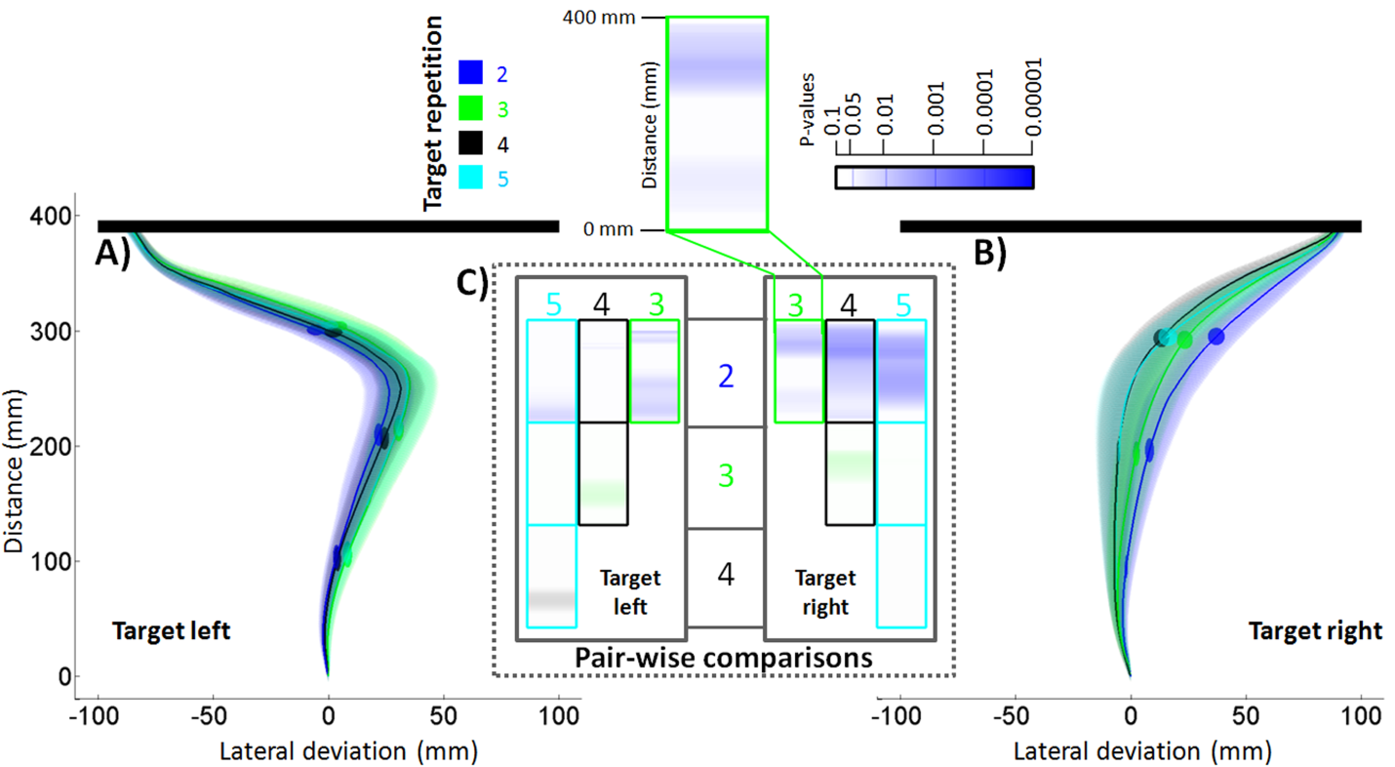
Figure S1: Averaged three-dimensional reach trajectories from all Switch trials after repeat-right (A) and repeat-left (B) micro-sequences shown from the Above view with formatting as in Figure 2. Each coloured trajectory represents reaching behaviour after a different length of repeat sequence: 2-Blue, 3-Green, 4-Black, 5-Cyan. C) Functional pair-wise comparisons between all possible pairs of trajectories (separated left and right) arranged as a matrix. Each row and column corresponds to different lengths of repeat-sequences with the intersection being the comparison between those two trajectories. Within each intersection box, the position of the coloured area corresponds to where along the reach distance (y) the trajectories differed in the lateral (x) dimension with the intensity of the colour corresponding to the magnitude of the statistical difference (see exploded box at top).

‘Miss’ Errors
Despite their exclusion from trajectory analysis, we examined the distribution of Miss errors across both the position within a repetition sequence (expressed as a percentage, Figure S2) as well as on Switch trials that occurred after a given length of sequence (expressed as the total number of misses, Figure S3). For each of these distributions, we broke the Miss errors into those that occurred when making reaches to the left (blue-bar-segment) as compared to the right (red-bar-segment). Overall, there was a higher proportion of misses during repeat-left than repeat-right trials (a testament to the rightward bias that is evident throughout our data, blue-bar-segments larger than red-bar-segments in Figures S2 and S3).
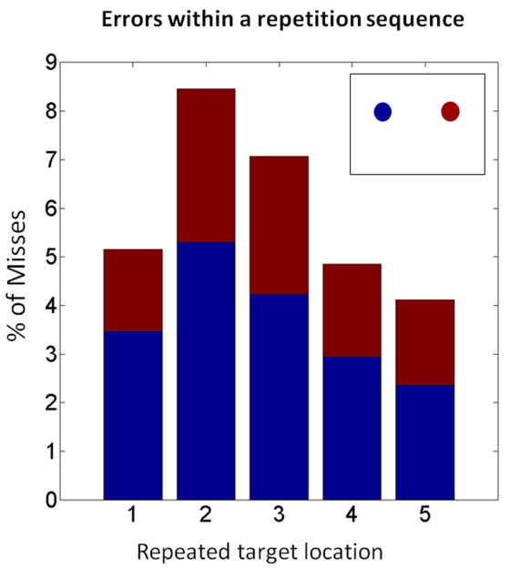
Figure S2: Percentage of Miss errors on Repetition trials across different positions within a repeat-sequence. Bars are broken into Misses on repeat-left trials (blue-bar component) and on repeat-right trials (red-bar component).

Examining the errors within a sequence (Figure S2) reveals an interesting pattern in which the highest percentage of miss trials was observed on the second and third trials of a repeat sequence. This suggests that participants may have employed a cognitive strategy and initially hedged their bets away from long sequences (guessing to the opposite side after one or two repetitions in a given direction), but after three consecutive trials to one side of space were content to use repetition as predictive of the upcoming location.
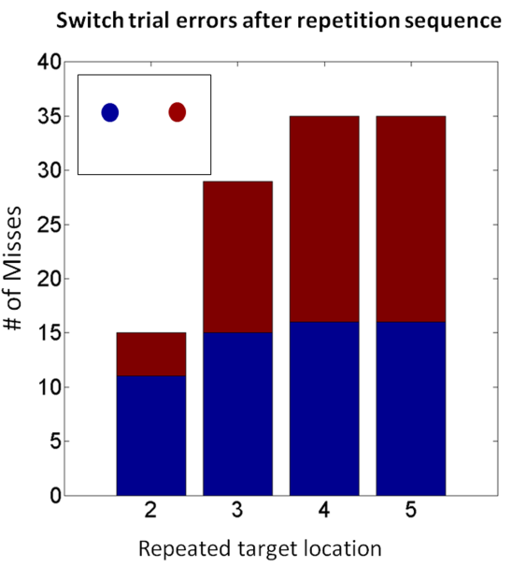
Figure S3: Total number of Miss errors on Switch trials after different lengths of a repeat-sequence. Bars are broken into Misses on cued-left trials following repeat-right sequences (blue-bar component) and on cued-right trials following repeat-left sequences (red-bar component).

When looking at the distribution of misses on Switch trials following different lengths of repeated sequences (Figure S3) two patterns emerge. First, participants made more errors after longer sequences, confirming the overall cumulative bias we report in the main manuscript. Second, the reported left versus right difference (faster build-up and earlier saturation for right bias) was also evident in that there were comparatively more misses on Switch trials following two right-repeated trials than two left-repeated trials. For consecutive sequences of three or more, however, the number of misses was comparable for the left and right.

Kinematic Analysis
We calculated participant averages on five dependent measures across all Repetition trials to characterize the sequence effects on temporal component of the reaches:
Reaction Time (ms): Time from the start of the trial (‘beep’) to the start button release.
Movement Time (ms): Measured as the time between start button release and touch screen contact.
Peak Velocity (mm/s): The highest vector velocity obtained during the reach.
Time to Peak Velocity: Time from the start of the movement until peak velocity was obtained.
Percent Time to Peak Velocity (%): The percent of movement time spent accelerating (Time to Peak Velocity / Movement Time).
Each of these five measures was entered into a two-factor (2x5: Cued-Side x Sequence-Position) repeated measures ANOVA to test for difference in the temporal components of reaches made to each side after a different number of repetitions toward that side. All RM-ANOVA results are reported with the Greenhouse-Geisser correction for sphericity. For all means of these variables across the two factors, see Supplemental Table 1.
 | Cued-Left |  |  |  |  | Cued-Right
Sequence-Position | 1 | 2 | 3 | 4 | 5 | 1 | 2 | 3 | 4 | 5
RxnTime (ms) | 230.27 | 232.69 | 234.70 | 232.20 | 233.36 | 232.12 | 229.76 | 231.48 | 233.53 | 230.95
MvmtTime (ms) | 459.17 | 464.01 | 448.60 | 434.04 | 427.54 | 387.10 | 385.20 | 381.64 | 375.71 | 376.12
PeakV (mm/s) | 2260 | 2221 | 2214 | 2172 | 2162 | 2263 | 2262 | 2290 | 2320 | 2339
TTPV  (ms) | 163.78 | 168.15 | 169.61 | 170.16 | 174.65 | 177.80 | 176.45 | 170.25 | 171.91 | 168.56
%TTPV  % | 34.33 | 35.40 | 36.80 | 37.67 | 39.53 | 42.73 | 42.33 | 41.33 | 42.27 | 41.33

Supplemental Table 1: Means of the five kinematic measures (Reaction Time (ms), Movement Time (ms) Peak Velocity (mm/s), Time to Peak Velocity (ms) and Percent Time to Peak Velocity (%)) on Repetition trials across all combinations of cue side and sequence position.

For reaction time, no significant effects of cue-side (F<1), sequence-position (F<1) or their interaction (F=1.03, p>0.3) were found. The overall null effect replicates our previous work [8] and suggests that our rapid-reach task was successful in inducing quick responses regardless of the trial type.
For movement time, we find that both cue-side (F(1,14) = 81.18, p<0.001) and sequence-position (F(2.65,37.12) = 4.62, p<0.01) significantly modulated the timing of reaches, but there was no interaction between the two. For the cue-side effect, we see that reaches to the right target location are much faster than reaches to the left, an effect that again replicates our previous work, and is probably biomechanical in nature. The sequence-position effect demonstrates that with consecutive trials to the same location, movement times become faster.
Analysis of the remaining three kinematic variables (peak velocity, time to peak velocity and percent time to peak velocity) provides further insight into the effect of decreasing movement times with increasing cue-repetitions, and demonstrates that it is likely due to different mechanisms on the left and right side. All three of these variables show a significant interaction between cue-side and sequence-position (peak velocity: F(2.32,32.53) = 6.86, p<0.01; time to peak velocity: F(1.89,26.47), p<0.05; percent time to peak velocity: F(2.12,29.72) = 11.18, p<0.001). Specifically, for reaches to cued-left targets, peak velocities go down with consecutive cues (1 to 5), as does the time and percent time to peak velocity. This is in contrast to reaches made toward cued-right targets where the peak velocity goes up with consecutive cues while the time to peak velocity comes down and the percent time to peak velocity stays relatively constant. At first pass, these results seem clear for reaches to the right target and confusing for reaches to the left target. For rightward reaches, the movement time decrease is simply reflecting that reaches get faster (higher and earlier peak velocities in the same relative position) as you perform consecutive reaches to the right side. However, for leftward reaches, how could the movement time decrease if the peak velocity also decreases with sequence-position? The answer is that the movement time decrease seen for leftward reaches is a result of the reaches becoming straighter with consecutive repetitions (see Figure 2). As the reaches straighten, participants are able to cover the same distance in less time. Since the reaches also tend less to the right with consecutive trials to the left, less of a leftward correction is required, resulting in lower peak velocities.

References:
1. Pelli, D.G. (1997). The VideoToolbox software for visual psychophysics: transforming numbers into movies. Spat Vis 10, 437-442.
2. Brainard, D.H. (1997). The Psychophysics Toolbox. Spat Vis 10, 433-436.
3. Ramsay, J.O., and Silverman, B.W. (2005). Functional data analysis, 2nd Edition, (New York: Springer).
4. Ramsay, J.O. (2000). Functional components of variation in handwriting. Journal of the American Statistical Association 95, 9-15.
5. Ramsay, J.O., Munhall, K.G., Gracco, V.L., and Ostry, D.J. (1996). Functional data analyses of lip motion. J Acoust Soc Am 99, 3718-3727.
6. Loehr, J.D., and Palmer, C. (2007). Cognitive and biomechanical influences in pianists' finger tapping. Exp Brain Res 178, 518-528.
7. Loehr, J.D., and Palmer, C. (2009). Sequential and biomechanical factors constrain timing and motion in tapping. J Mot Behav 41, 128-136.
8. Chapman, C.S., Gallivan, J.P., Wood, D.K., Milne, J.L., Culham, J.C., and Goodale, M.A. (submitted). Reaching for the unknown: Multiple target encoding and real-time decision making in a rapid reach task. Cognition.

