ENGR280 Quiz 4

Tuesday, Nov. 8, 2005, 11:30-12:20 Time: 30 Minutes
ELL 168 (TA: Craig) and ELL061 (TA: Le)
Close Book, 1 page of formula sheet and a simple calculator allowed.
Please write on the paper: Student Name: Student Number: Email:

Note: You have to write down the formula and calculation steps for all the problems. Answers without supporting formula and steps or curves will not get any marks.

(1) A city is considering increasing its airport capacity. Two mutually exclusive alternatives are being considered. Alternative A is to construct a new airport 65 kilometers from the city. Alternative B is to enlarge and otherwise upgrade the current airport that is only 15 kilometers from the city. Benefit and cost data are shown in Table 10.2. The city will use a MARR of 9% and a 12-year time horizon for this project. What are the benefit-cost ratios for the two alternatives? Which alternative should be accepted? [5 marks]

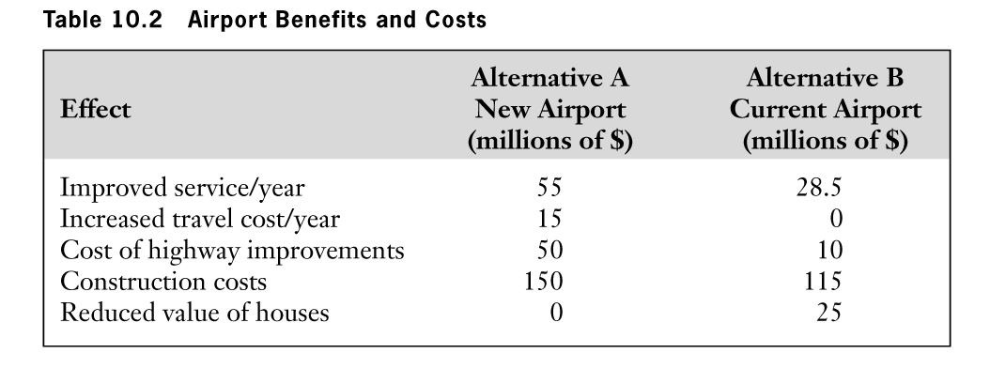
(2) Waxworks is considering buying a new wax melter for their line of replicas of statues of government leaders. They have two choices, Finedetail and Simplicity. The proposals are shown in Table 11.3. Which is the preferred supplier? (a) As sales vary from 50,000/year to 200,000/year? [2 marks] (b) As the “other costs” per unit for the Simplicity model range from $0.1/unit to $0.5/unit, and sales 60,000 units? [3 marks]
Use break-even charts for this question (2), both (a) and (b).
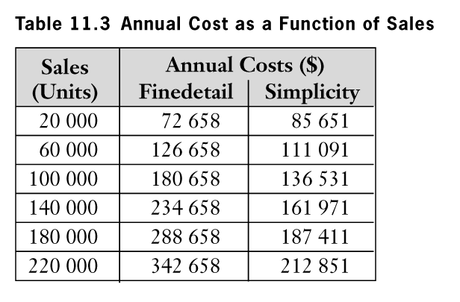

For reference, DO please double check!
(1) First, we convert all costs and benefits to PW
F= (P/A,9%,12)=7.16
PW(improved service of A) = $55(P/A,9%,12) = $55*F =X=393.835
PW(improved service of B) = $28.5(P/A,9%,12) = $28.5*F=Y=204.0885
PW(increased travel cost of A) = $15(P/A,9%,12)= $15*F=Z=107.415
[2 marks]
- The benefit-cost ratios for both alternatives are:

BCR(A) = X/($150+$50+Z) = 393.835/(150+50+107.415)=1.2811
BCR(B) = Y/($10+$115+$25) =204.0885/(10+115+25)= 1.3606
[2 marks]
- Both benefit-cost ratios exceed one, thus both are viable.
- To decide which alternative is better, we must compute the benefit-cost ratio of the incremental investment between the alternatives.
- Start with the project with the smallest present worth of costs (B) , and compute the BCR associated with the marginal investment:

BCR (A – B)= (BA – BB)/(CA – CB)
=(X – Y – Z)
($50 + $150) – ($10 + $115 + $25)
= 1.6470 [1 mark]
- The ratio is greater than one. We interpret this to mean that the benefit-cost ratio ranks the new airport (A) ahead of the current airport (B).
(2) (a) is apparent the second is better, (b) need to analysis: when addition> and < 0.26, we have different answers (0.26 no need to be accurate, get from chart).
0.5
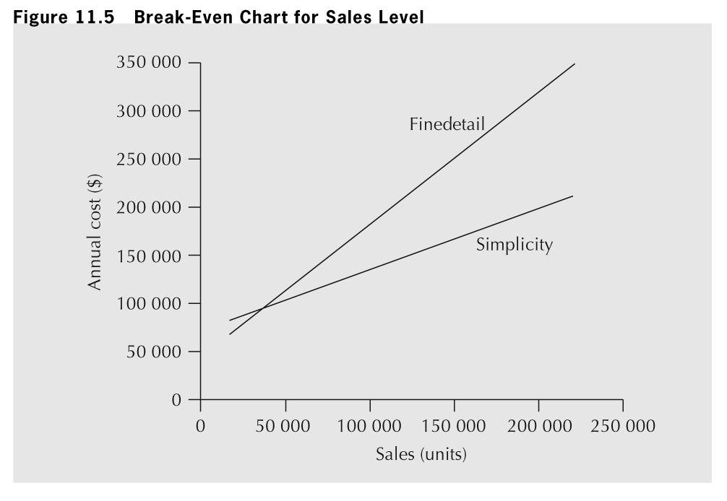
0.1
0.5
0.2699

