ENGR280 Quiz 5

Wednesday, Nov. 23, 2005, within class time 11:30-12:20 Time: 30 Minutes
ELL 168 (TA: Craig) and ELL061 (TA: Le)
Close Book, 1 page of formula sheet and a simple calculator allowed.
Please write on the paper: Student Name: Student Number: Email:

(1) Mackenzie Meats has several alternatives for an effluent treatment system. Two criteria have been considered, present worth and discharge purity. Find three most efficient choices from the figure below and explain how the choice is made. [3 Marks]

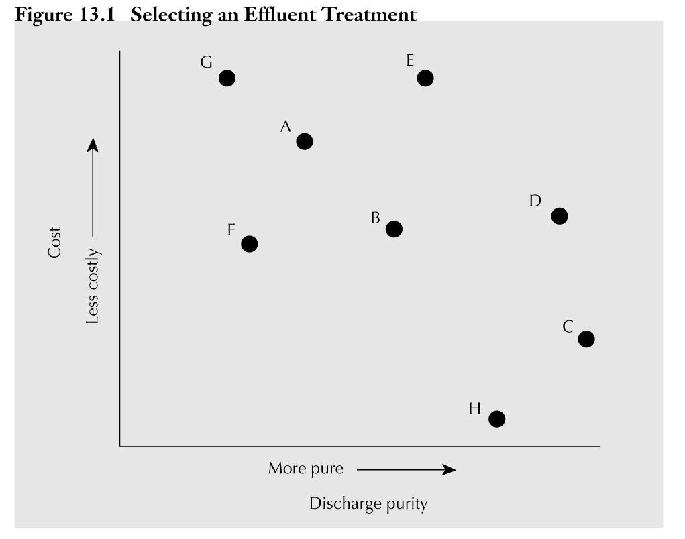

(2) You are testing three solder joints on a printed circuit board. Every solder can either be open (O) or closed (C). Determine the PDF for the random variable X, the number of open joints in three tested joints. The probability that a single tested joint will be open is 10%. Show your calculation step by step. [7 marks]

For reference, DO please double check!
(1) E, D and C

(2) Solution: X can take on four possible values:
0.5

x1 = 0, x2 = 1, x3 = 2, and x4 = 3. [1 marks]

Test Number of
Sequence “Opens” Probability
(O,O,O) 3 0.001 = 0.1 × 0.1 × 0.1
(O,O,C) 2 0.009 = 0.1 × 0.1 × 0.9
(O,C,O) 2 0.009 = 0.1 × 0.9 × 0.1
(C,O,O) 2 0.009 = 0.9 × 0.1 × 0.1
(O,C,C) 1 0.081 = 0.1 × 0.9 × 0.9
(C,C,O) 1 0.081 = 0.9 × 0.9 × 0.1 [please double check …..]
(C,O,C) 1 0.081 = 0.9 × 0.1 × 0.9
(C,C,C) 0 0.729 = 0.9 × 0.9 × 0.9 [3 marks: miss one -0.5]

the PDF for X, the number of “open” joints in the three tests is:
Pr(X = 0) = p(x1) = 0.729 Pr(X = 1) = p(x2) = 0.243
Pr(X = 2) = p(x3) = 0.027 Pr(X = 3) = p(x4) = 0.001 [4 marks]

